2010年中考英语模拟试卷（三）
第I卷（选择题 共60分）
一、听力（每小题1分，共20题，满分20分）
第一节
每小题你将听到一个对话，从A、B、C 三幅图中找出与你所听内容相符的选项。每段对话读一遍。
( ) 1.A. B. C.
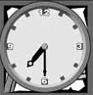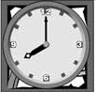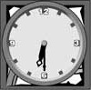
( ) 2. A. B. C.
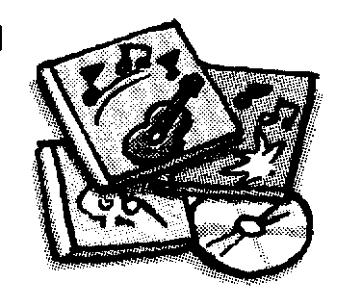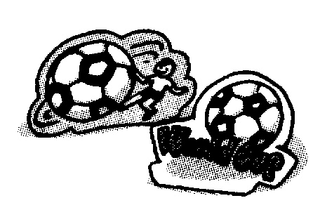
( ) 3. A. B. C.

( ) 4. A. B. C.

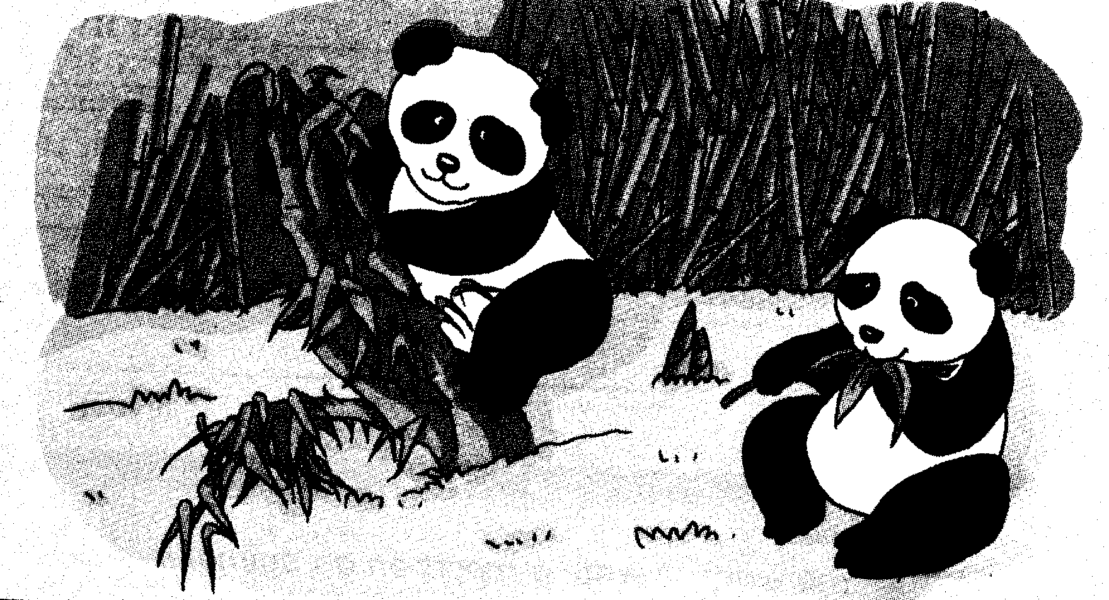
( ) 5. A. B. C.
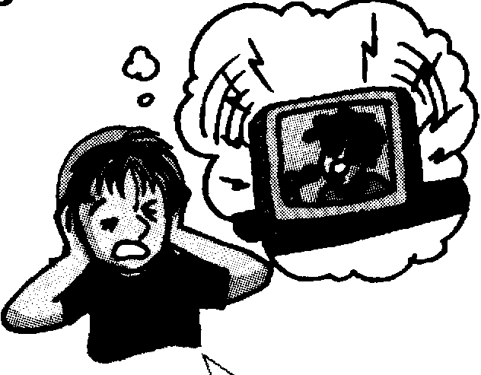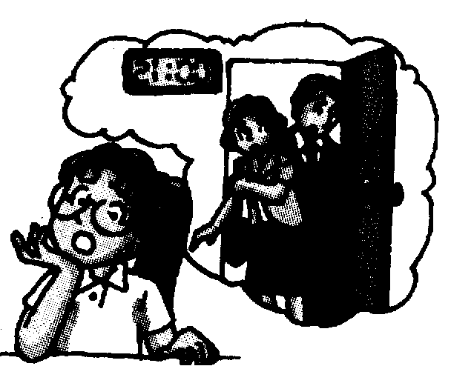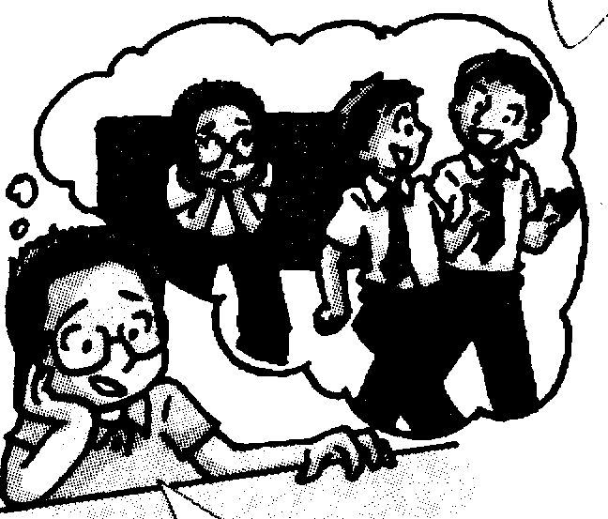
第二节（本节共15小题）
听下面的对话或独白，每段对话或独白后有几小题，请根据你所听到的内容，从所给的A、B、C 三个选项中选出一个恰当的答语。听每段对话或独白前，你都有时间阅读各个小题，每小题5秒钟；听完后，各个小题将给出5秒钟的作答时间。每段对话或独白读两遍。
听第6段材料，回答6-7题。
6. Where is Bill?
A. He is at home. B. He has gone to his hometown.
C. He has gone to Jianglin.
7. What’s Nick’s telephone number?
A. 5512 3468 B. 8512 3465 C. 5212 3486
听第7段材料，回答8-10题。
8. What happened yesterday?
A. A car accident. B. A fire. C. An earthquake.
9. What did Zhang Hua do?
- She saved Mrs Sun out of fire.
- She sent Mrs Sun to the hospital.
- She called 110 and put out the fire.
10. How long did she have to stay in hospital?
A. Two weeks. B. Three days. C. A week.
听第8段材料，回答11-15题。
11. Which city will the man go to?
A. He will go to Haikou. B. He will go to Beijing. C. He will go to Nanjing.
12. How does he want to go there?
A. By train. B. By coach. C. By air.
13. When will he take the plane?
A. At 8:15 p.m. on November, 26th.
B. At 8:15 a.m. on November, 26th.
C. At 8:30 a.m. on November, 26th.
14. How many people will go with the man?
A. Only one. B. Three. C. Four.
15. How much money will the man pay for the four tickets?
A. 1,000 yuan. B. 3,000 yuan. C. 4,000 yuan.
听第9段材料，回答16-20题。
16. Which school does Li Qingyue come from?
A. No. 54 Middle School. B. No. 45 Middle School. C. No. 40 Middle School.
17. Why did she choose such an English name?
A. Because she thought she was as lovely as an angel.
B. Because she wanted to be an angel.
C. Because her parents liked the name.
18. What’s her hobby?
A. She likes watching news. B. She likes reading. C. She likes sports.
19. What’s she going to be when she grows up?
A. She wants to be a news reporter.
B. She wants to be a sports reporter.
C. She wants to be a player.
20. What is she like?
A. She looks tall and slim.
B. She is strong and outgoing.
C. She looks little but she is outgoing.
二、单项填空（共15小题；每小题1分，满分15分）
21. She had __________ accident, but luckily, she wasn't hurt in _______ event at all.
A. a, a B. an, an C. an, the D. the, an
22. Whose school uniform is this? It’s _______.
A. her B. my C. his D. your
23. James enjoys _______. He has a lot of CDs in his locker.
A. reading books B. listening to music
C. watching TV D. drawing pictures
24. There ______ an important exam next Saturday. We need to prepare for it.
A. will have B. are C. is D. will be
25. --How much did you _______ all these stationary?
--About 80 yuan.
A. cost B. spend C. pay for D. take
26. --Would you like to go for a picnic this weekend? Let’s enjoy the fresh air outside.
--__________. It will be a sunny day.
A. I’d love to B. Don’t mention it
C. No, I won’t D. It doesn’t matter
27. ________ supper, I usually have some rice, meat and vegetables.
A. On B. For C. Of D. In
28. Sandy used to eat fast food. But now she _____ eats them. So she is becoming much healthier.
A. usually B. seldom C. often D. always
29. _______ people are waiting to watch the raising of the national flag at Tian’anmen Square.
A. Thousands B. Two thousands C. Thousand of D. Thousands of
30. Tom has been in this company _________he left school.
A. when B. since C. as soon as D. whether
31. –What did your father ask you? -He asked me ___________.
A. whom I was chatting with B. where am I with my friends
C. when would I go home D. If I have finished my homework
32. Boys and girls, I have got ________ to tell you. Please listen to me carefully.
A. important something B. anything important
C. nothing important D. something important
33. Look! Each of the students _________ a book silently. It’s a good way to learn language.
A. are reading B. read C. is reading D. watch
34. Traveling by train is ____________ than by air, but it has its own advantages.
A. slower B. easier C. dearer D. more comfortable
35. James wrote a play for television. And it ________ by an American TV company.
A. buys B. has bought C. bought D. was bought
三、完形填空（共10小题；每小题1分，满分10分）
All living things on the earth need other living things to live with. Nothing lives 36 . Sometimes one living thing kills 37 . Each kind of life eats another kind of life 38 live, and together they form a food chain(食物链). Some food chains are simple, while others are not. But 39 food chains begin with the sun, and all food chains become 40 if one of the links disappears.
All life needs sunlight to live on. But only plants can use 41 directly(直接地). They make food from sunlight, water, air and so on. Animals can only use the sun’s energy 42 it has been changed into food by plants. Some animals feed directly on plants. Others eat smaller animals. Meat-eating animals are only 43 plants indirectly.
What about human beings? We are members of many food chains. We eat wheat, rice, vegetables, fruit and so on. We also eat meat and drink milk. But 44 often break up the food chains. They kill wild animals. They also make rivers, lakes and seas dirty. When these rivers, lakes and seas are polluted, the fish in them 45 be eaten. If people eat the fish, they will get strange diseases.
Each form of life is linked to all the others. Breaking the links puts all life in danger.
36. A. alone B. lonely C. together D. happily
37. A. other B. the other C. another D. the others
38. A. for B. so that C. and D. in order to
39. A. any B. all C. some D. most
40. A. better B. broken C. stronger D. nicer
41. A. moonlight B. laser light C. sunlight D. bright light
42. A. after B. before C. until D. by the time
43. A. making B. catching C. eating D. feeding
44. A. sunlight B. animals C. plants D. people
45. A. can B. cannot C. must D. needn’t
四、阅读理解（共15小题；每小题1分，满分15分）
(A)
Dear Sir,
I am writing to you about my stay at your hotel. My wife and I arrived on Saturday, 15th May and stayed for a week. Though we were treated well and found the service excellent, we think there are one or two matters we should bring your attention.
1. We had hoped for a nice holiday from our busy work lives, and your advertisement said “comfortable and quiet”. We want to have a chance to enjoy ourselves. However, we were always waken up by the noise every morning. Is it really necessary for the workers to start their repair work so early?
2. We had hoped to swim in your “wonderful pool”. To our disappointment(失望), we found that it was closed for the whole time of our stay.
I hope you do not mind my writing to you about these things, but I would be happy if you could give me some explanation. As I said at the start, it is a pity, and your service is so good in other fields.
I hope to hear from you soon.
Yours sincerely
Mr Hector Bradley
46. Whom is Mr Hector Bradley probably writing this letter to?
A. His friend. B. The owner of a hotel. C. An editor. D. His father.
47. When did they get to the hotel?
A. On 15th May. B. Three days ago. C. Last year. D. On a cold winter morning.
48. What’s the main idea of the second paragraph (段落)?
A. The hotel was very comfortable and quiet.
B. The workers in the hotel were very hard-working.
C. He thought the hotel hadn’t provided them a quiet place.
D. The service in the hotel was very excellent.
49. What did Mr Bradley think about the swimming pool?
A. He felt disappointed because the swimming pool was closed for the whole time of their stay.
B. He felt disappointed because the swimming poop was too small.
C. He felt pleased with it because he had a good time there.
D. He found it really wonderful, just like what was said in the advertisement.
50. What kind of letter is it?
A. An invitation letter. B. A thank-you letter.
C. A recommendation letter D. A complaint letter.
(B)
Canada 4:00 a.m. to 8:30 a.m.
Canada is a big country with six time zones(时区). In the west, it is four a.m., and everyone is asleep, but in the east it is half past eight and people are awake. It is a cold Friday morning in November.
Scotland 12:00 noon
Scotland is part of the UK. The capital of Scotland is Edinburgh, and the capital of the UK is London. It is twelve noon, or midday, in Edinburgh. Children are having lessons, but they are looking forward to the weekend because there is no school on Saturday and Sunday.

Egypt 2:00 p.m.
Friday is already the weekend in Egypt. Friday is a special day for Muslims, so schools, offices and shops are closed in all Arab countries. So now, at two p.m., most people in Egypt are having lunch with their families.
Japan 9:00 p.m.
Japan is seven hours ahead of Egypt, so it is already Friday evening there. The weekend is beginning. Most people are out with friends or watching television or playing computer games.

51. If it is 8:00 a.m. in western Canada, the time is _______ in eastern Canada.
A. 12:00 B. 2:00 p.m. C. 12:30 p.m. D. 4:00 a.m.
52. While Canadian children are waking up, children in Scotland are ________.
A. having lessons B. sleeping C. watching TV D. playing games
53. Who needn’t go to work on Fridays?
A. Canadians. B. Scots. C. Japanese. D. Egyptians.
54. Which country will welcome Saturday first, Canada, Japan, UK or Egypt?
A. UK B. Japan C. Egypt D. Canada
55. What does “ahead of” mean in English?
A. earlier than B. later than C. after D. until
(C)
What’s the meaning of “dark horse”? It’s someone who wins when no one expects it.
Han Xiaopeng took China’s first gold on snow. He became an Olympic “dark horse” last Thursday by winning the gold medal in men’s freestyle aerial skiing(自由式滑雪空中技巧) at Turin in Italy. He made two almost perfect jumps for the highest score. Han had never won a world gold medal before, let alone(更不用说) in the Olympics!
“I never thought this would happen,” said the 23-year-old. “I feel like I’m in a dream.” It’s China’s second gold medal at the Turin Olympics. But more important, Han’s gold was the country’s first ever in a snow sport. In 2002, China’s Yang Yang won the gold for speed skating at the winter Olympics in Salt Lake City, US.
Just because Han’s win was unexpected doesn’t mean that he didn’t work hard.
Han grew up in Jiangsu Province. Before he started his training on snow, he used to be an acrobat(杂技演员) at a circus. In 1995, a coach found his talent(才能). The coach, Yang Er’qi, said Han had the agility(灵活性) and courage to be a ski jumper. When Yang first took the 12-year-old to northern China, the boy couldn’t swim, skate or ski. But he wasn’t afraid of the high platform(跳台) and kept on training.
Han almost left the sport after hurting his knee months before the Salt Lake Games. In that Olympics he only got 24th. “I was hopeless at that time, but my family and the coach stood firmly(坚强地) behind me, helping me through,” he recalled.
Han Xiaopeng worked so hard that he won the gold medal in the Olympics at last. Because of his success, more and more people in China are becoming interested in skiing. We are proud of him and we hope he will have another big success in the next winter Olympics.
56. What does ‘dark horse’ mean? It means _____________.
A. a horse which is dark B. someone who is expected to win
C. a horse which likes living in the dark D. someone whose win is unexpected
57. Where did Han Xiaopeng take China’s first gold on snow?
A. In China . B. In Italy. C. In America. D. In Australia.
58. What made the coach, Yang Er’qi, choose Han Xiaopeng to be a ski jumper?
A. He had the agility and wasn’t afraid of the high platform.
B. He was good at skiing though he was only 12 years old.
C. He was born in the north of China and liked sports on snow.
D. He had the talent and he had won a world gold medal before.
59. Which of the following sentences is NOT TRUE according to the passage?
A. He was 23 when he won the gold medal at the winter Olympics.
B. He made two almost perfect jumps and got the highest score.
C. No one had won the gold before Han Xiaopeng at the winter Olympics.
D. He never gave up even though he had faced many difficulties.
60. What is the best title for this passage?
A. A Dark Horse at the Winter Olympics B. A Wonderful Match
C. A Hopeless Snow Game D. An Exciting Horse Race
第II 卷（非选择题 共50分）
五、填空与改错（共20小题；每小题1分，满分20分）
A）根据括号中所给的汉语写出单词，使句子意思完整正确。
61. Everyone should try to be _____________(有礼貌的) and helpful to others.
62. In order to get to the nearest village, we have to walk _______________ (穿过) a bridge.
63. –May I ___________(借) your dictionary? I left mine at home.
--Of course. Here you are.
64. He was so careless that he wore different socks on his _____________(脚).
65. There are _____________(较少的) apples in this basket. I prefer that one.
B）根据句子意思，用括号中所给单词的适当形式填空。
66. The second Sunday in May is ___________(mother) Day.
67. Would you please explain the word as ____________(clear) as you can? We still can’t understand it.
68. Whose drawing is ______________(bad), Tom’s, yours or Jim’s?
69. How exciting the match is! I ___________ never ____________(see) such an exciting match before.
70. Mr Zhu asked us ____________(give) out some leaflets at the charity show.
C）下列各句A、B、C、D中有一处错误，请在不改变句子意思的前提下，将正确的答案写在题后的横线上。
71. We are going hiking on Zijin Mountain if it won’t rain tomorrow,.
A B C D ( ) __________
72. Traffic mustn’t cross the roads when the traffic lights are red. Walkers mustn’t do it, too.
A B C D
( ) __________
73. Although he was very tired, but he still cleaned the classroom before he left.
A B C D ( ) __________
74. He couldn’t walk as fast as the others because his bad leg?
A B C D ( ) __________
75. It’s hard of Sandy to finish the work in an hour.
A B C D ( ) __________
D）根据短文内容，从下面方框中选择适当的单词或词组填空，使短文内容完整正确。
is fond of else be able to would rather easy-going
Millie: Do you think Peter would be a good monitor?
Kitty: Yeah, he’d 76.___________________ organize things well. But I don’t think he is 77.________________ enough. He can’t get on well with the others.
Millie: Who 78.________________ would be better?
Kitty: I 79.________________ vote for Daniel because he is very helpful. He 80.________________ doing extra work for class.
Millie: I agree with you.
六、阅读短文（共15小题；第81~85小题每小题2分，第86~95小题每小题1分，满分20分）
A）根据短文内容，按要求答题。
Every Saturday, Grandpa and I walk to the nursing home to visit some of the old and sick people there because they can’t take care of themselves.
First we visit Mrs. Sokol. I call her “The Cook.” She likes to talk about the time when she was a well-known cook in Russia. People would come from miles, just to taste her chicken soup.
Next we visit Mr. Lipman. I call him “The Singer” because he loves to sing for us. Whenever he does, his voice fills the air, clear and full of energy.
I also enjoy Mrs. Kagan’s stories about her own experiences during the old days. I call her “The Memory Lady.”
One day Grandpa got very sick and the doctor said they didn’t think he would get better.
It was time to visit the nursing home again. I had to go alone. Everyone was surprised when I told them that my grandpa was ill and in hospital.
A few days later, Grandpa was not able to sit up, eat and even speak. I went to the corner of the room so Grandpa wouldn’t see me cry. Suddenly, I heard someone singing. I looked up. It was The Singer. Behind her were The Cook. and The Memory Lady. The Cook brought her famous homemade chicken soup. The Memory Lady held Grandpa’s hand and told us how Grandpa once came to visit her in a snowstorm, just to bring her some roses for her birthday.
Before I realized it, visiting hours were up. That evening, Grandpa called the nurse in and said he was hungry. Soon he began to sit up. Finally he was able to get out of bed. It is really a miracle (surprising event), isn’t it?
81. Why did the writer and his grandpa go to the nursing home every Saturday?
_______________________________________________________________________
82. Who were Grandpa’s good friends in the nursing home?
_______________________________________________________________________
83. Why did the writer cry?
_______________________________________________________________________
84. Please put the sentence “ Before I realized it, visiting hours were up.” into Chinese?
_______________________________________________________________________
85. What do you think of Grandpa?
________________________________________________________________________
B）根据短文内容及首字母提示，填写所缺单词，将答案按序号填入下面表格内。
Recently, many English teachers from universities all over China came together. They discussed h 86 to use newspapers to teach English. Wu Ping, a university professor, said that her university has b 87 a course on newspaper reading for freshman English majors. They use English newspapers to t___88____. It is said that the s 89 enjoy the course. “They say newspapers help them learn English, and also tell them the latest news a 90 the world,” he said.
Outside the classroom, English newspapers are thought by many people to be o 91 of the most important and effective ways to learn English. One of the professors believes that newspapers are better t 92 other teaching materials in four ways. First, the stories are i 93 and can get the students to read on. S 94 , the language is modern and up-to-date. Newspapers cover lots of topics like sports, culture, e 95 and so on. And last but not least, the language is very practical, and can be used in our daily life.
86. h________ 87. b________ 88. t_________ 89. s________ 90. a________
91. o________ 92. t_________ 93. i_________ 94. S________ 95. e________
七、书面表达（满分10分）
下个学期，我们每一位同学即将进入新的学校。请你根据下列提示，以“New School, New Life” 为题，用英文写一篇80词左右的短文，谈一谈你的新学校、新生活、新打算，（注：文章的开头已给出，不计入词数）
- What kind of new friends and teachers would you like to have?
- What do you think your new school life will be like?
- How will you improve yourself in the future?

New School, New Life
I’m a student in a secondary school and will graduate in two months. I hope to ____________
________________________________________________________________________________________________________________________________________________________________________________________________________________________________________________________________________________________________________________________________________________________________________________________________________________________________________________________________________________________________________________________________________________________________________________________________________________________

听力原稿：
第一节
每小题你将听到一个对话，从A、B、C 三幅图中找出与你所听内容相符的选项。每段对话读一遍。
- A: Excuse me. May I know the time?
B: Sure. It’s half past six.
A: Thank you.
2. –Can I help you?
--I would like some hair clips to match my favourite T-shirt.
3. –What does this sign mean?
--It means you should go straight on.
4. –Come here! Look at the picture of Tuantuan and Yuanyuan!
--What lovely animals! They will be sent to Taiwan from Sichun.
5. --It’s too noisy at home. I can’t focus on my study.
--Why not talk about it with your parents? Maybe they can turn down the TV while watching it.
--Good idea. I’ll try it. Thanks a lot.

第二节（本节共15小题）
听下面的对话或独白，每段对话或独白后有几小题，请根据你所听到的内容，从所给的A、B、C 三个选项中选出一个恰当的答语。听每段对话或独白前，你都有时间阅读各个小题，每小题5秒钟；听完后，各个小题将给出5秒钟的作答时间。每段对话或独白读两遍。
听第6段材料，回答6-7题。
--Could I speak to Bill, please?
--Sorry, he’s out at the moment.
--When will he come back?
--I don’t know. He has gone to JiangLin on Business. Can I take a message for you?
--Thanks. Please ask him to call me back. This is Nick. My phone number is 5512 3468.
--5512 3468. OK, I’ll tell him as soon as he comes back.
--Thanks a lot.
--You are welcome
听第7段材料，回答8-10题。
--Tom, Zhang Hua didn’t come this morning. What’s up?
--Didn’t you read the newspaper this morning?
--What happened to her?
--There was a fire in Zhang Hua’s building. She heard her neighbour, Mrs Sun, calling for help and saw a lot of smoke from next door. She called 119 at once and helped Mrs Sun out.
--How brave!
--But the fire burned her legs and face. She had to stay in hospital for seven days.
--Oh, what a pity! Is she getting better now?
--Yes. She will come back soon.
--I’m very happy to hear that.
听第8段材料，回答11-15题。
Woman: Hello! This is Happy Flight. What can I do for you?
Bill: Hello! Could you tell me how much it is to fly to Haikou?
Woman: Where do you fly from?
Bill: From Beijing.
Woman: The price of a ticket from Beijing to Haikou is 1,000 yuan.
Bill: Is there a flight in the morning on November, 26th?
woman: Just a minute, please. Yes. There is one at 8:15 a.m. on that day.
Bill: Great!
Woman: How many tickets do you want?
Bill: I'd like four tickets, please.
Woman: OK. Four tickets on November 26th to Haikou. Have a good trip!
Bill: Thank you very much. Bye!

听第9段材料，回答16-20题。
Hello! My name is Li Qingyue. I come from No. 45 Middle School in Hefei. You can call me Angle. I chose this English name because I think I am as lovely as an angel. Do you think so?
I’m a little girl. I don’t look very strong at all. But I am more outgoing than most kids. And sport is my favourite activity. Every day, I watch the sports news. I know about many sporting events. If you ask me questions about them, I can tell you a lot very easily. I also like doing sport in my free time you may ask me why I love sports so much. It’s because the spirit of sport moves me. I have wanted to be a sports reporter since I was ten years old. So you might be able to see me on CCTV-5 in ten years’ time.

2005-2006第二学期初三英语期中检测
参考答案：
I. 1-5 CBACA 6-10 CA BAC 11-15 ACBBC 16-20 BACBC
II. 21-25 CCBDC 26-30 ABBDB 31-35 ADCAD
III. 36-40 ACDBB 41-45 CACDB
IV. 46-50 BACAD 51-55 CADBA 56-60 DBACA
V. A) 61. polite 62. across 63. borrow 64. feet 65. fewer
B) 66. Mothers’ 67. clearly 68. worst 69. have seen 70. to give
C) 71. D doesn’t 72. D either 73. B 删除 74. D because of 75. A for
D) 76. be able to 77. easy-going 78. else 79. would rather 80. is fond of
VI.
A) 81. Because the old and sick people in the nursing home can’t take care of themselves.
82. They were Mrs Sokol, Mr Lipman and Mrs Kagan. / the Cook, the Singer and the Memory Lady.
83. Because Grandpa was badly ill. / Grandpa couldn’t sit up, eat and even speak.
84. 我还没意识到，探视时间就结束了。/ 在我意识到之前，探视时间就结束了。
85. He is helpful/ kind/ warm-hearted…
B) 86. how 87. begun 88. teach 89. students 90. around
91. one 92. than 93. interesting 94. Second 95. education
VII.
I’m a student in a secondary school and will graduate in two months. I hope to study in a beautiful high school. I want to have lots of good friends. My new teachers will be very friendly to me and I can learn a lot from them. In the new school, we will have enough time to do after-school activities. The life will be very colourful. If I have some problems in the new school, I can go to a ‘buddy club’ for help. In the future, I will do my best to improve myself. I believe I will be better and better.

